1. Go to the path where selenium jar file is downloaded and enter cmd in the address bar

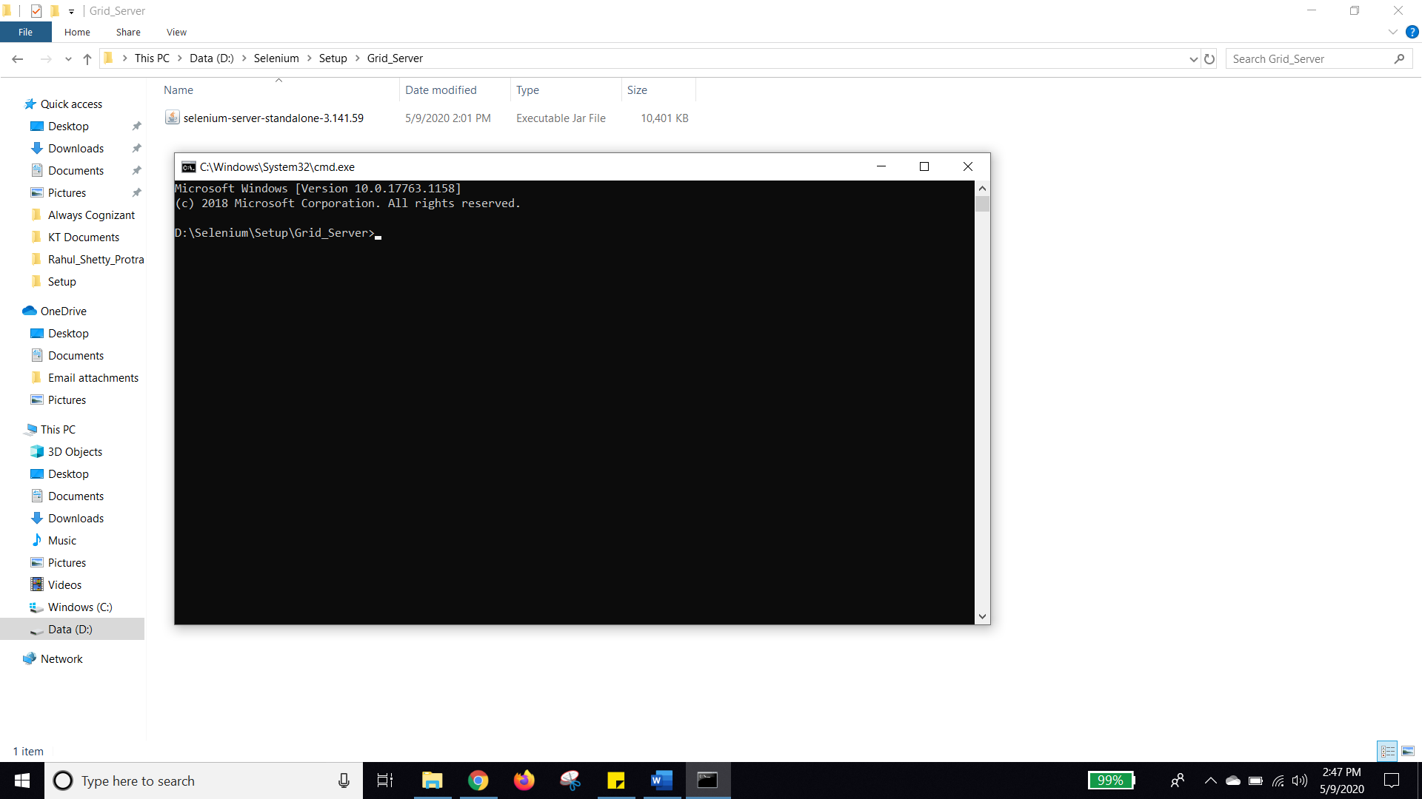

1. Enter the command and register the hub. Copy the name from the jar name and add.jar with the rest of the command.

Command : **“java -jar selenium-server-standalone-3.141.59.jar -role hub”**

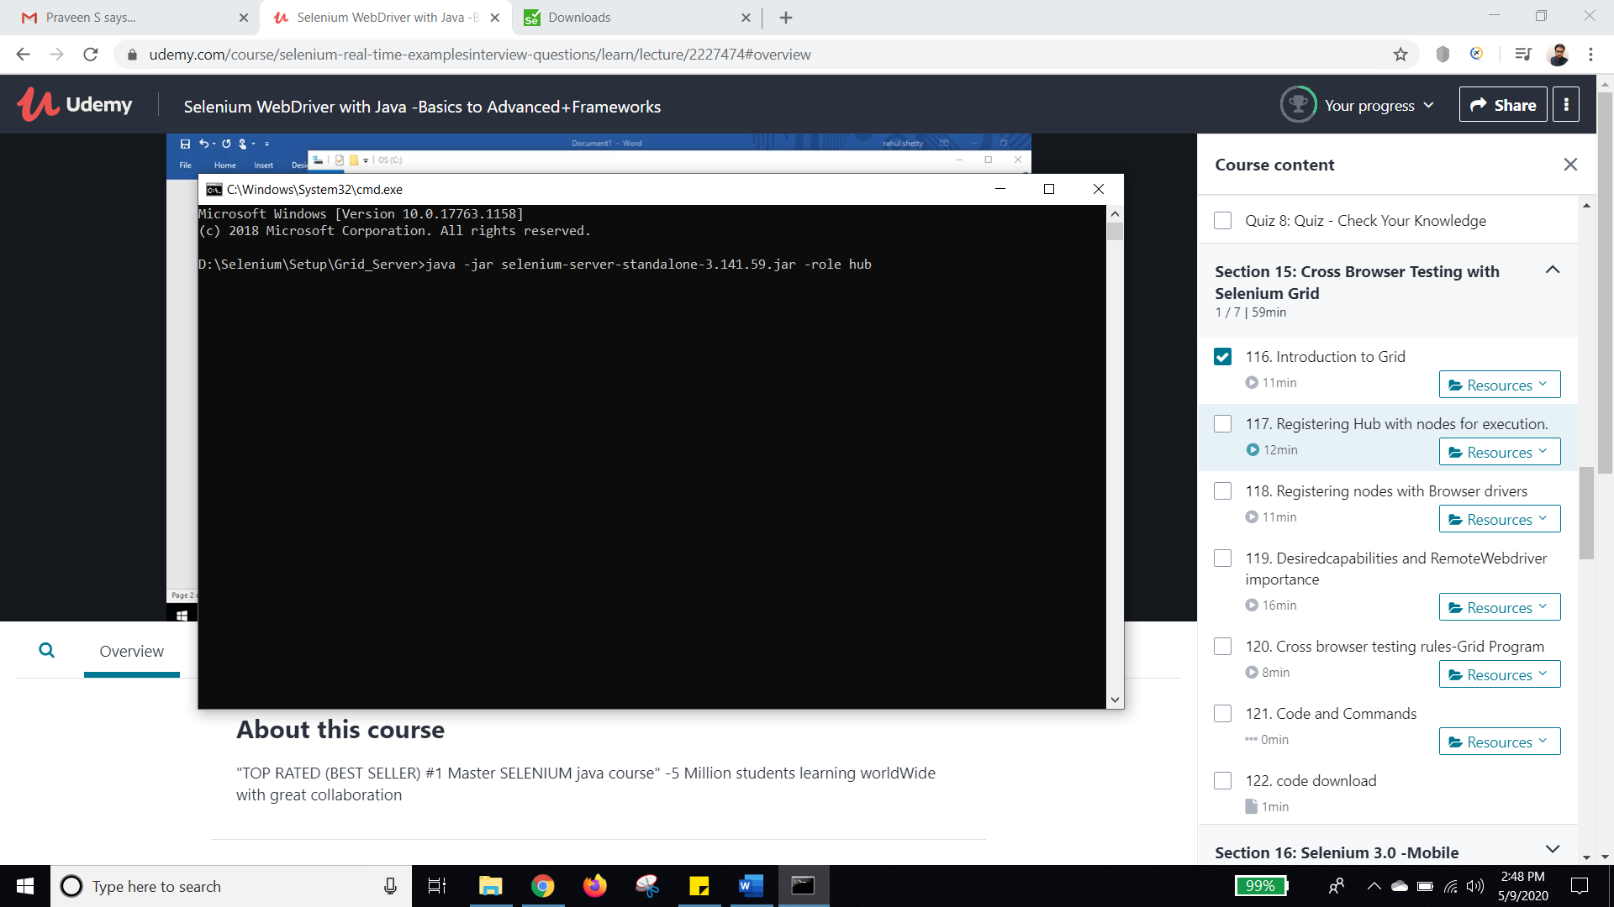

1. The following command should be displayed

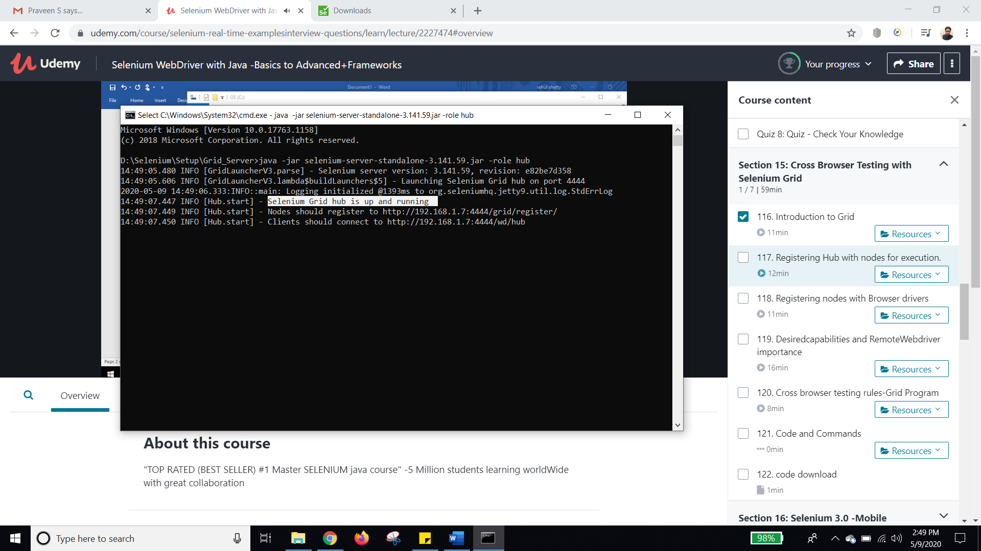

1. Enter the node URL. Add /console and hit the URL to verify whether the server is running

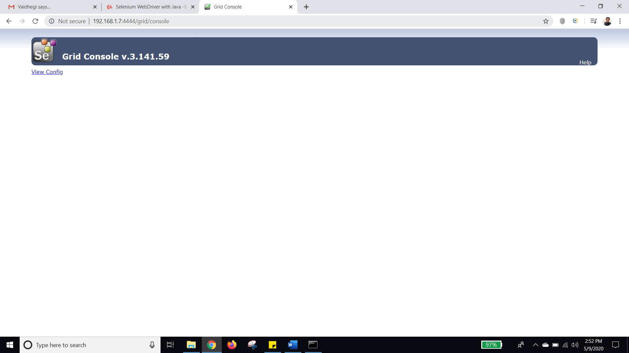

1. Login to the machine which is one of the nodes (Node machine)
2. Download the **Selenium server jar** in the node machine as well
3. Invoke the jar (Like previous) in the node machine as well in the path where jar is placed

Command : **“java -jar selenium-server-standalone-3.141.59.jar -role webdriver -hub** [**http://192.168.1.7:4444/grid/register**](http://192.168.1.7:4444/grid/register/) **-port 5566”**

-Here, webdriver means node

**(Here, the IP address is taken from the hub machine as shown below)**

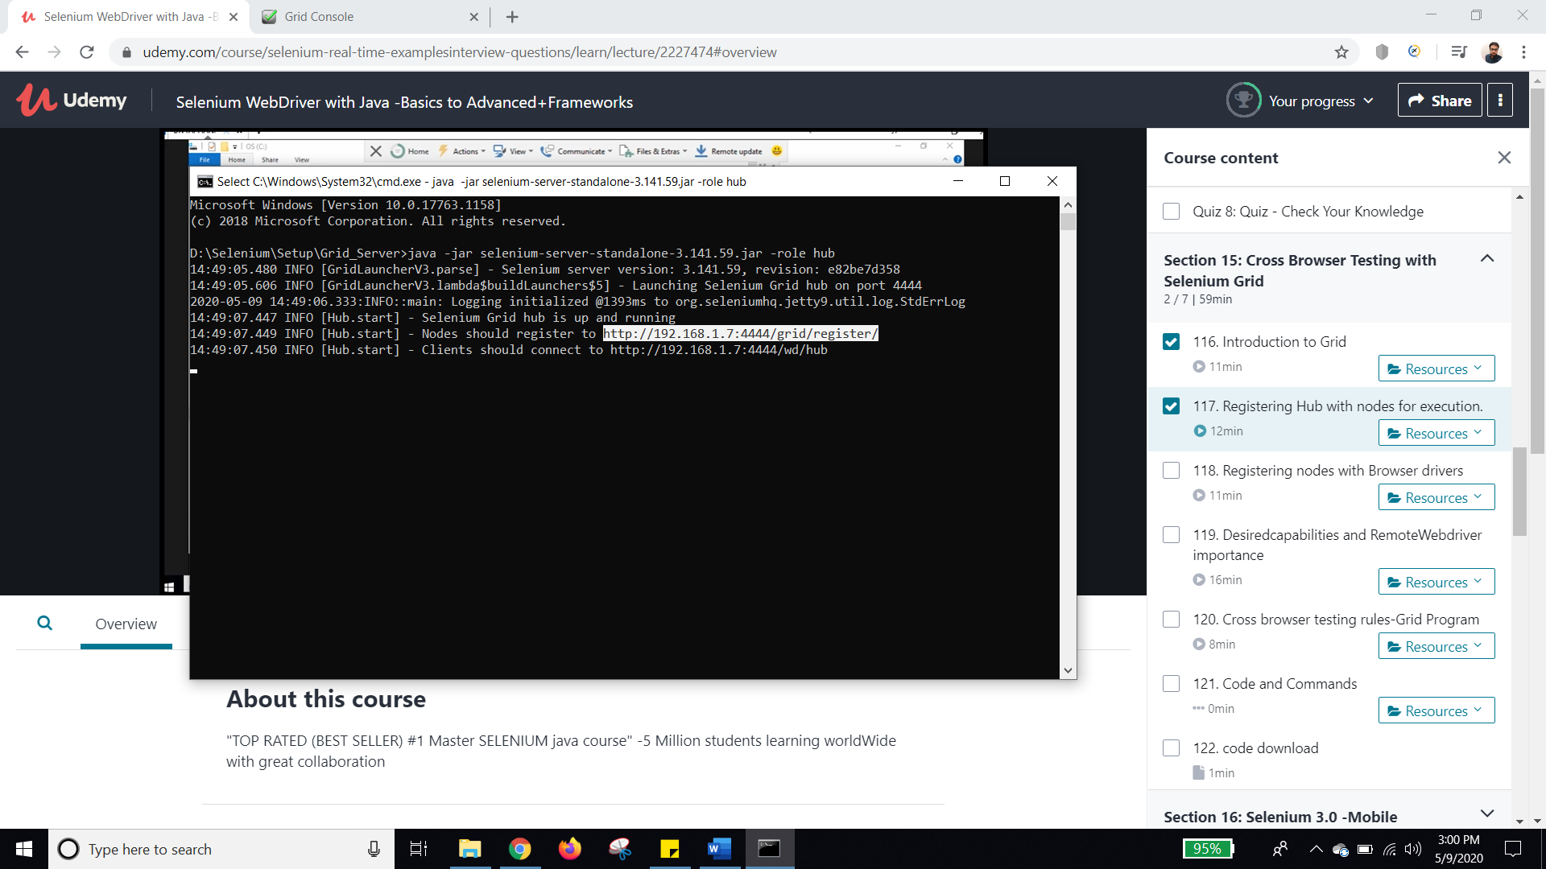

**Also, specify the port number so that node listens to that port 5566. Hub listens to the port 4444**

1. The node machine now looks like this.

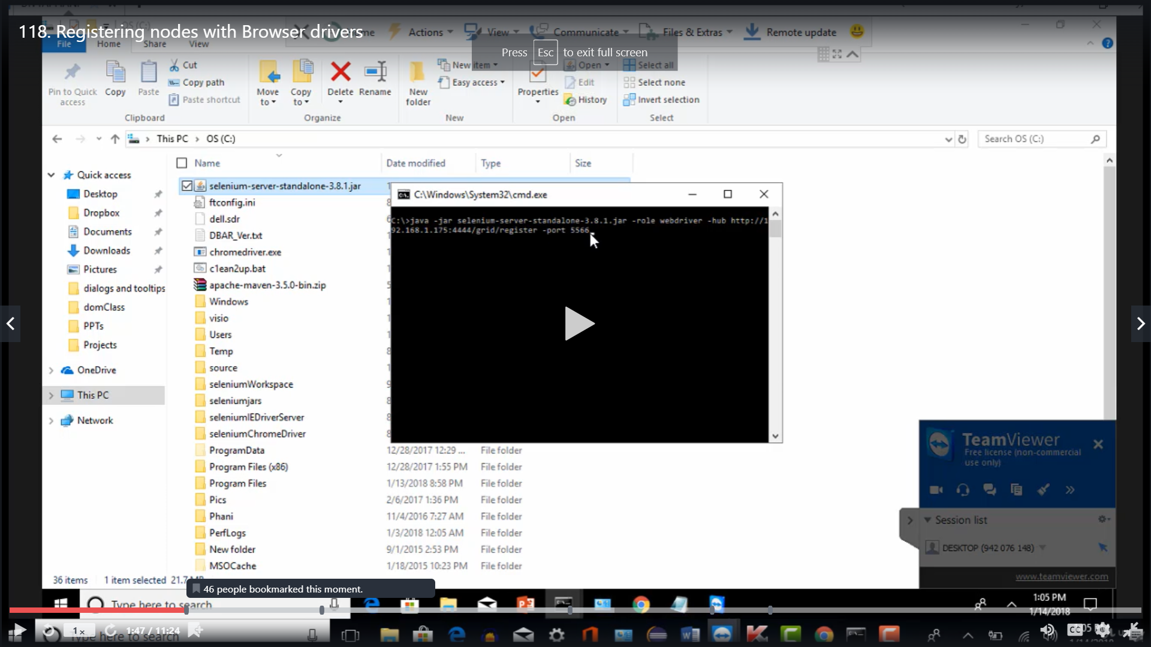

1. After running this from node, it looks like this.

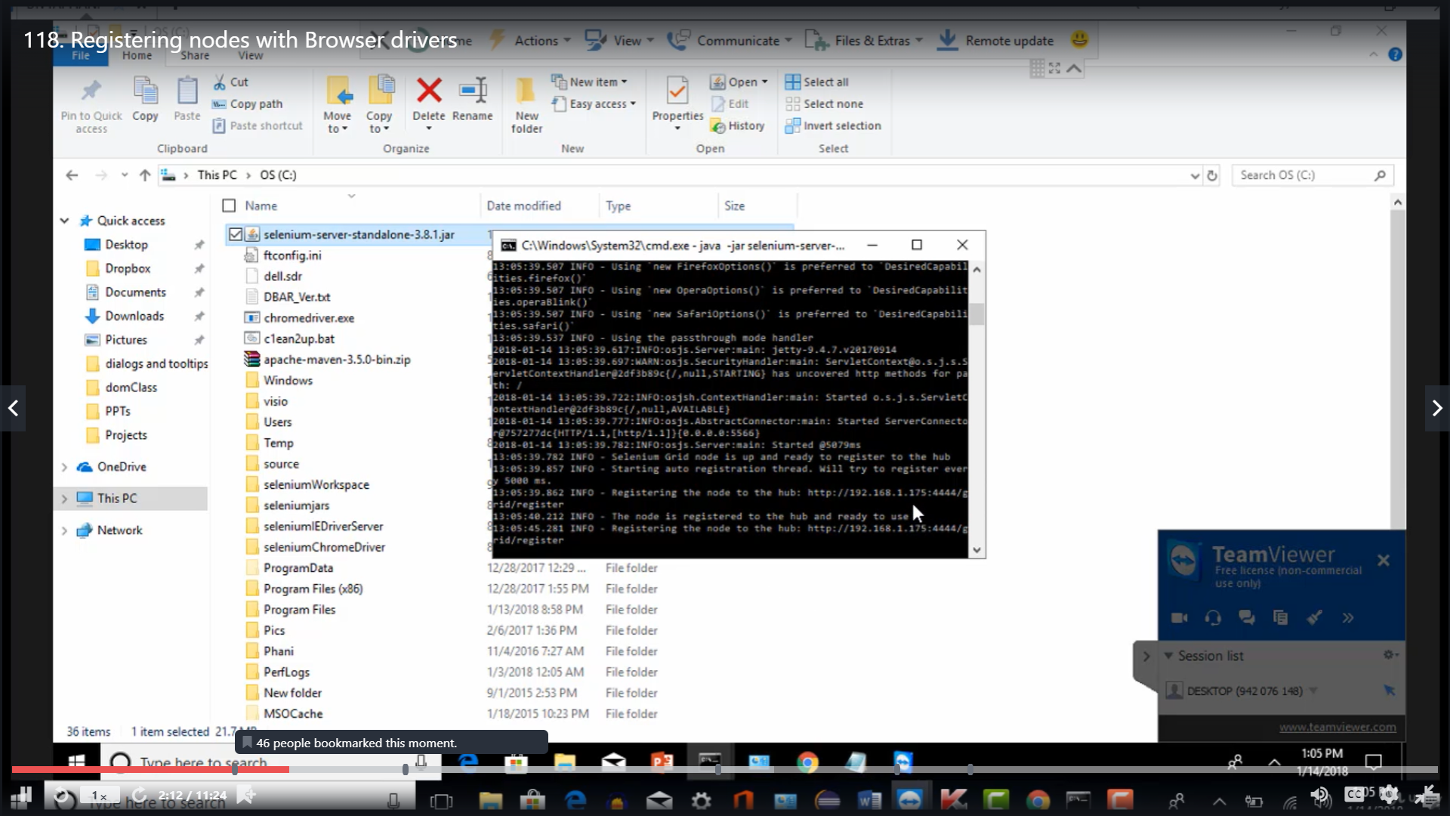

1. After node is registered, in Hub the cmd prompt gets updated like this

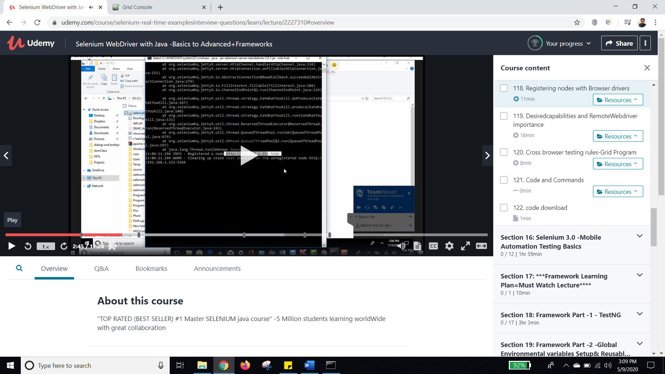

1. Make sure that Java is configured properly in system variables.
2. Also, the driver for the browser in which test cases has to be run should be configured in Node machine. So place the chromedriver or geckdriver in the same folder as that of SeleniumStandalone jar and run the command

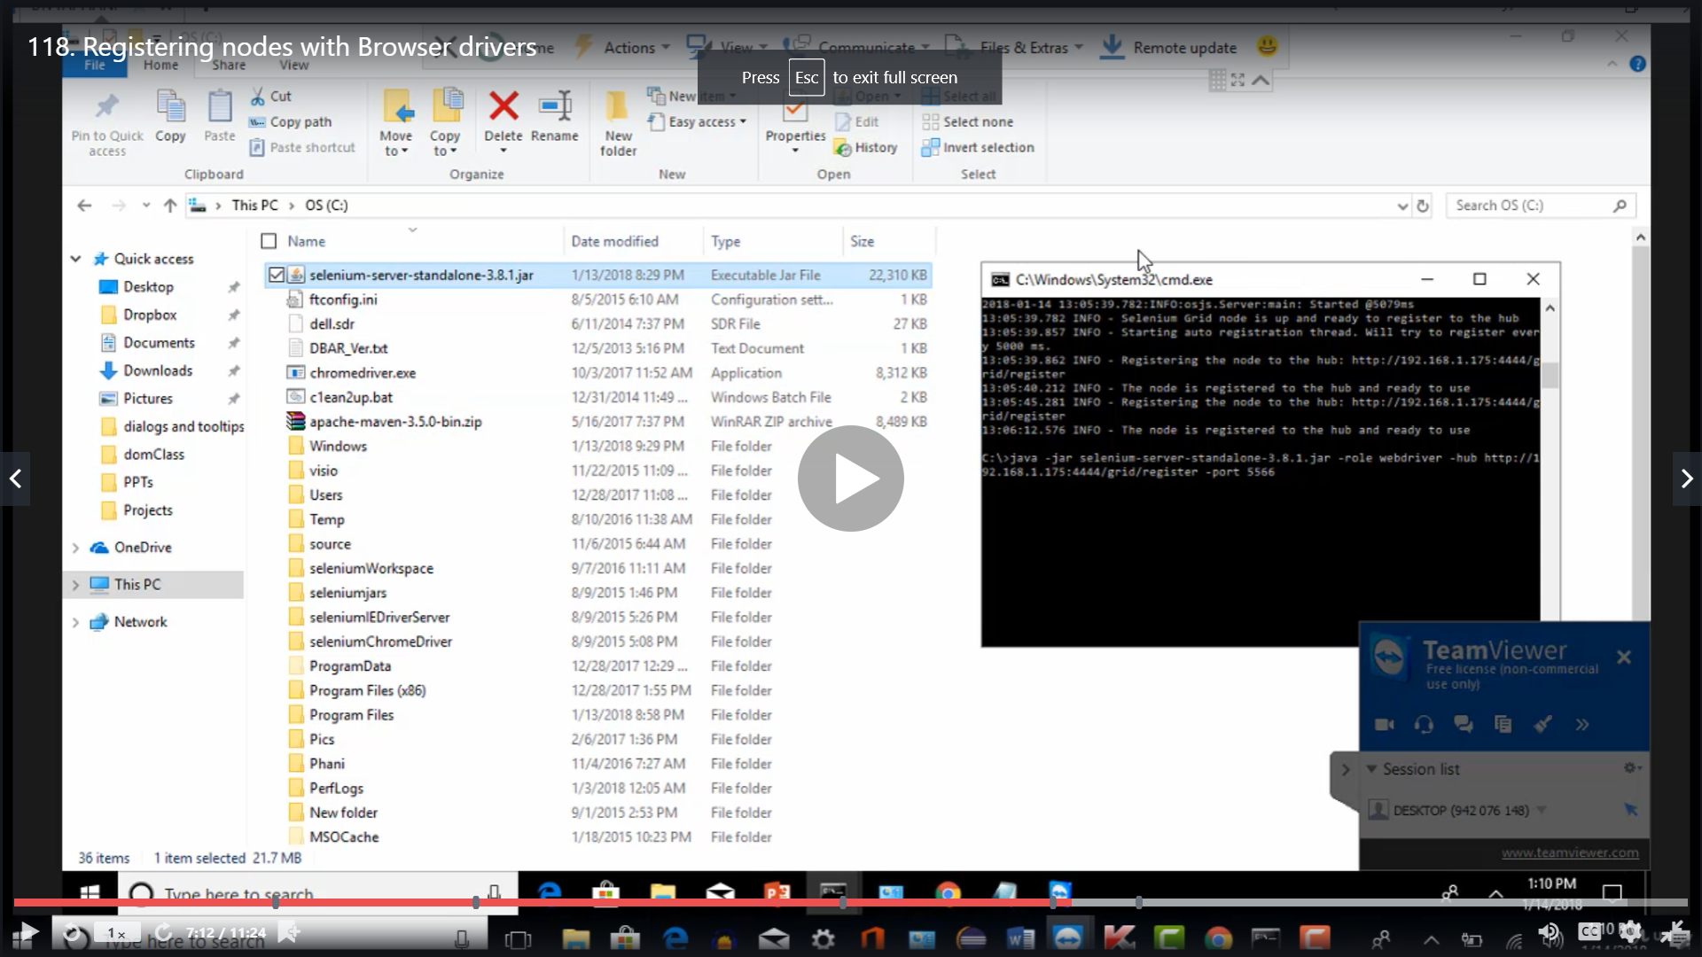

1. Now update the command as follows so that the knowledge of browsers can be given.

Command : **java -Dwebdriver.chrome.driver=”C:\chromedriver.exe” -jar selenium-server-standalone-3.141.59.jar -role webdriver -hub** [**http://192.168.1.7:4444/grid/register**](http://192.168.1.7:4444/grid/register/) **-port 5566**

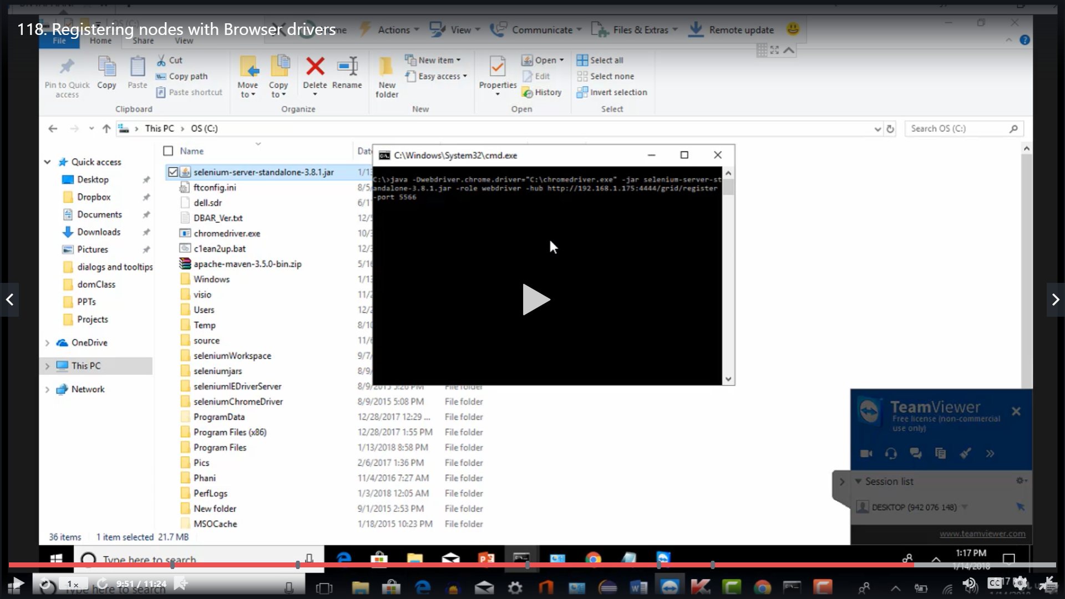

1. The selenium grid will be installed in the node

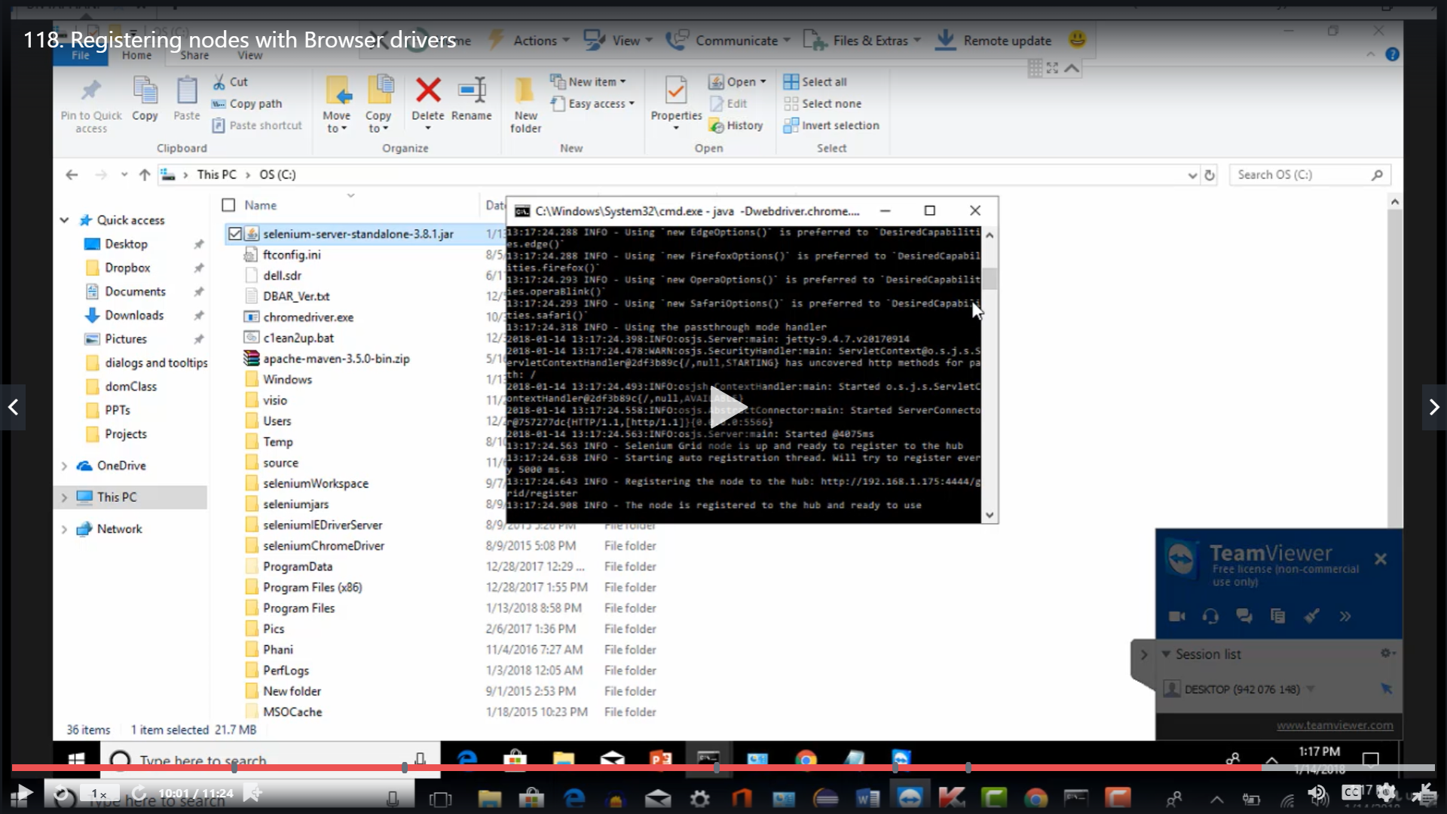

1. The grid console looks like this. Node ip address, how many browsers can be run etc. The test case gets allocated to any of the browsers in the nodes by the Grids.

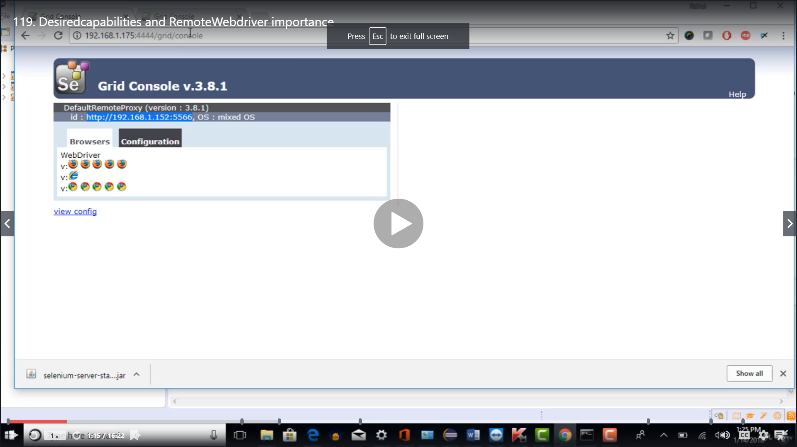

1. In the host, attach selenium server jar in the java class file.
2. All the properties to run a test case are defined in DesiredCapabilities. Ex : Which browser to run, Which OS to run etc.

**DesiredCapabilities dc = new DesiredCapabilities();**

**dc.setBrowserName(“chrome”);**

**dc.setPlatform(“Platform.WINDOWS”);**

**WebDriver driver = new RemoteWebDriver(new URL(“http://192.168.1.7:4444/wd/hub”),dc);**

**driver.get(**[**https://www.google.com**](https://www.google.com)**);**

--- Write the server URL from the link where the hub is sitting. Can also write

**WebDriver driver = new RemoteWebDriver(new URL("http://localhost:4444/wd/hub"), dc);**

